Weekly Research Report Studio 6

Student name : Zihan Liu

Report date : 31/05/2024

What did you do this week?

*Outline briefly what you did this week and what you achieved.*

*Redesign the UI of homepage and navigation.*

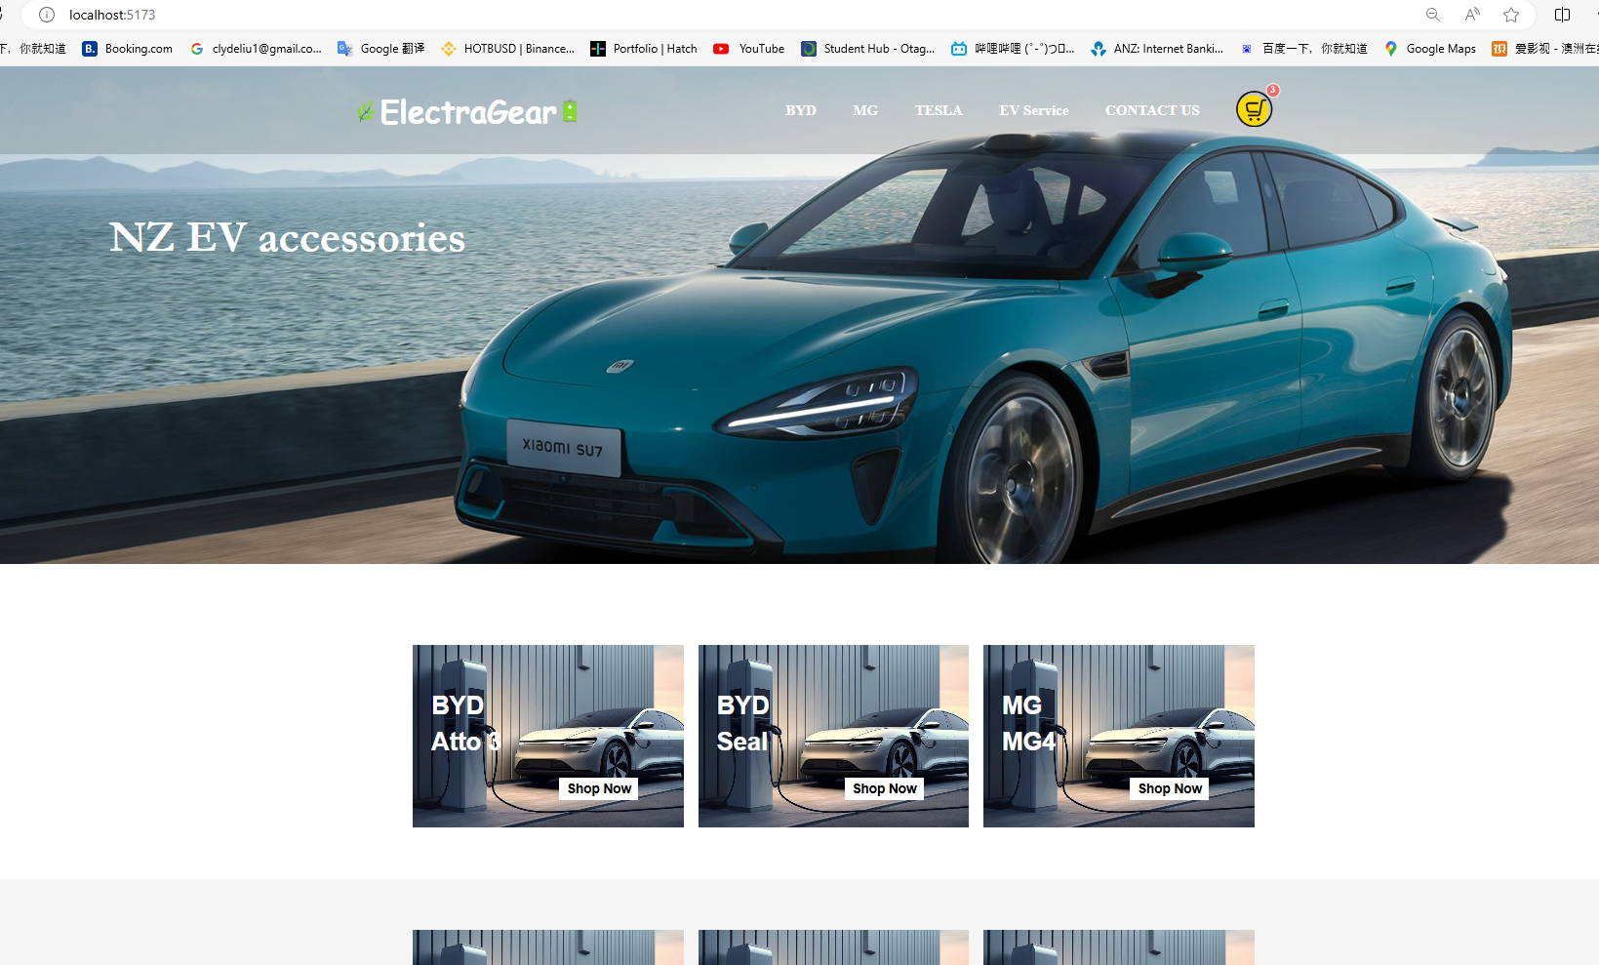

*Checkout page has been implemented with payment module.*

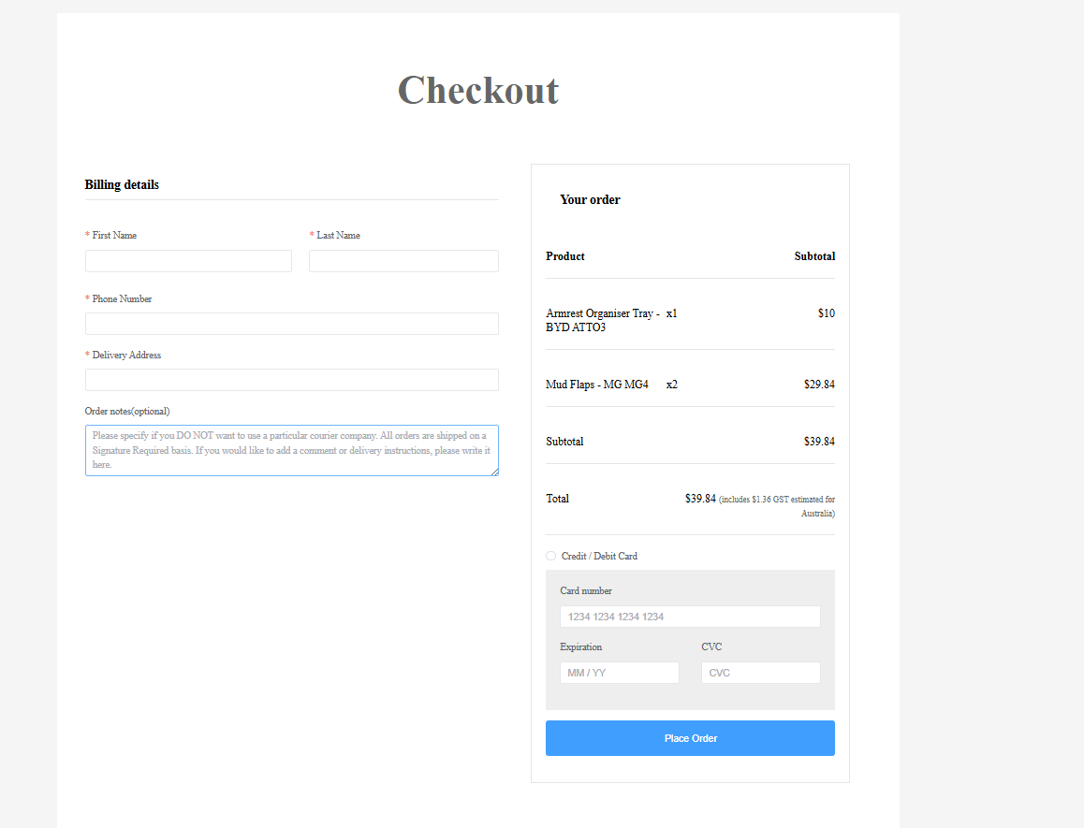

Set up input conditions when registering

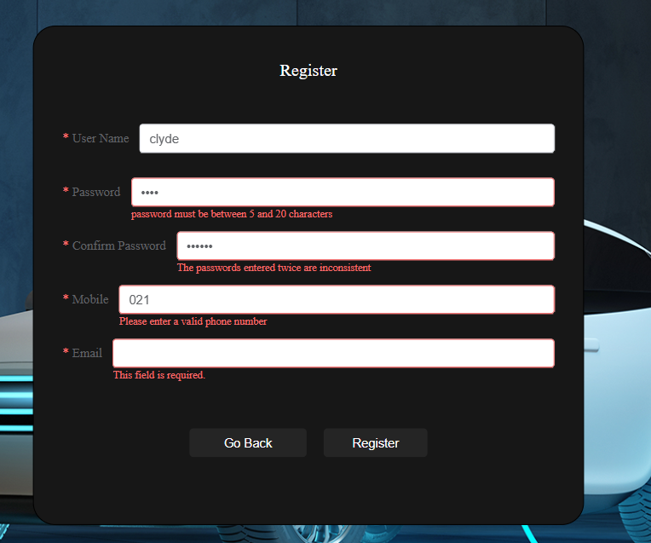

Keep updating trello

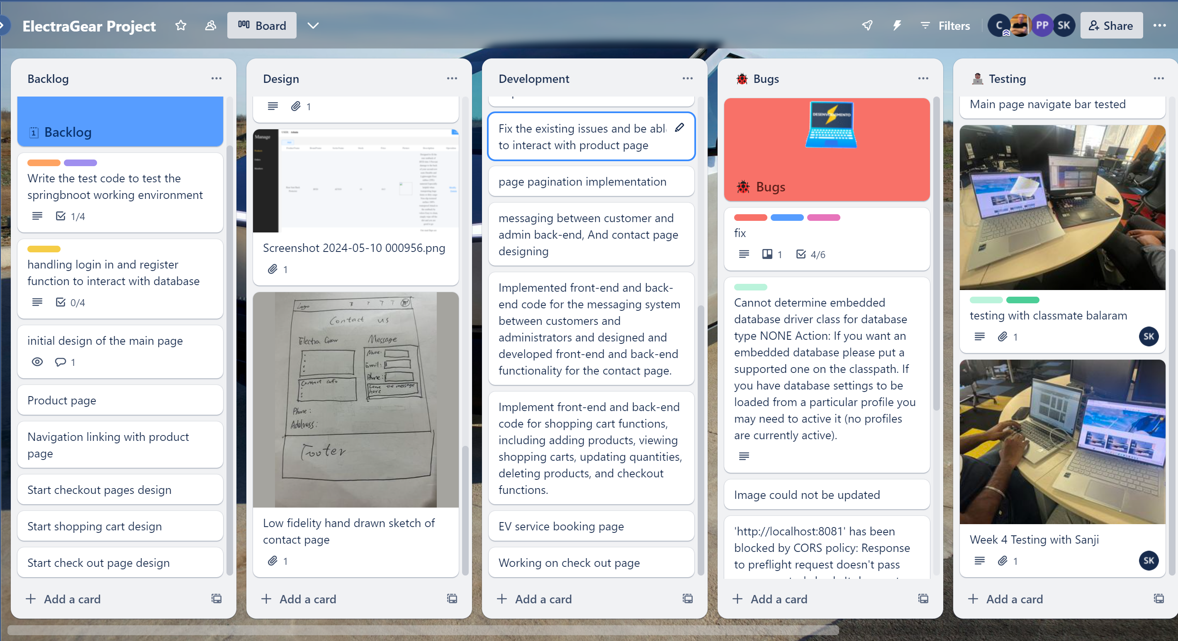

What are you planning to do next week?

*Describe what you plan to do next week and what you want to achieve.*

*Make all the pages footer and header consistent.*

**

*Improve contact us page UI*

*Make the customer reservation in ev service booking page, can be sent to admin end.*

*Improve shopping cart functionalities can be interact with database and improve UI quality*

*Keep updating the Trello. Testing with classmates of my booking page and shopping cart if finished.*

Do you need help with anything?

*What can your supervisor help you with? Make a list of things we can work on together.*

Am I on track now? besides can you give some suggestions of the aspects could be prioritized for improving the functionality of the shopping cart, except the UI.